7-1P

<https://github.com/brayden276/Brayden-SIT323>

https://youtu.be/xw2ZGmrc2FE

Components:

As below, our App.jsx, which uses components to create the page.

As below our Firebase Storage:  
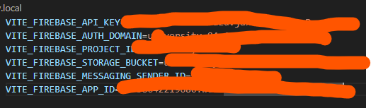

\*

Then as below the rendered webpage:  
